Project Information Report – Godrej Woods

- Project Summary
Sales Status: Sustenance
Construction Status: Excavation is currently in progress for Towers A, B, and C D. For Tower A, B, C & D excavation has been completed and foundation work has commenced. For rest of the towers commencement of upper basement.

Configurations (all of them) & Pricing (in crs.)
Configuration | Saleable Area/SBU Size (sq. ft.) | Pricing Range (Agreement Value) | Pricing Range (Agreement Value + GST) | Pricing Range (Agreement Value + GST+SDR)
2 BHK | 1193 - 1242 sq. ft. | 1.70 Cr. | 1.70 Cr. + 5% | 1.70 Cr. + 5% + 7.6%
3 BHK Premium | 1888 sq. ft. | 2.50 Cr. | 2.50 Cr. + 5% | 2.50 Cr. + 5% + 7.6%
3 BHK Lux | 2143 - 2305 sq. ft. | 2.80 Cr. | 2.80 Cr. + 5% | 2.80 Cr. + 5% + 7.6%

RERA: Possession & OC Timelines
  - RERA Number: PRM/KA/RERA/1251/472/PR/121125/008248
  - Possession Timeline As Per RERA (Month and Year): Nov 2030
  - Possession Timeline Target As Per GPL (Month and Year): Dec 2029
  - OC Timeline As Per RERA (Month and Year):
  - OC Timeline Target As Per GPL (Month and Year):

- 20:80 Payment Plan
  - Payment Plan - 20:80 Freedom Offer

How it will work for this project (with demo illustration of the calculation):

2 BHK Cost Sheet
Total Cost For Customer |  | 1,81,39,173
Total Agreement Value |  | 1,70,77,227
Milestone - 20:80 Freedom Plan | % | Amount | Logic
On Booking | 5% | 8,96,554 | 5% of Agreement Value + additional 5% GST of that value
Within 15 Days from the Date of Booking | 5% | 8,96,554 | 5% of Agreement Value + additional 5% GST of that value
Within 60 Days from the  Date of Booking | 10% | 17,93,109 | 10% of Agreement Value + additional 5% GST of that  value
On Application of Occupancy Certificate | 70% | 1,25,51,762 | 70% of Agreement Value + additional 5% GST of that value
On Notice of Possession | 10% | 17,93,109 | 10% of Agreement Value + additional 5% GST of that  value
On Notice of Possession: Advance Maintenance & Sinking Fund Charges | 0% | 2,08,085 | Advanced Maintenance & Sinking Fund Charges + 18% GST of Advanced Maintenance Value
Total |  | 1,81,39,173

Additional SDR Charges (changes during handover from year to year; starting from 7%) at the time of possession
* This illustration is for representation purposes only. The actual calculation and monthly payout may vary depending on the (i) unit selected (ii) associated charges for that unit and (iii)
the offers available at project marketing office.

Floor Plans

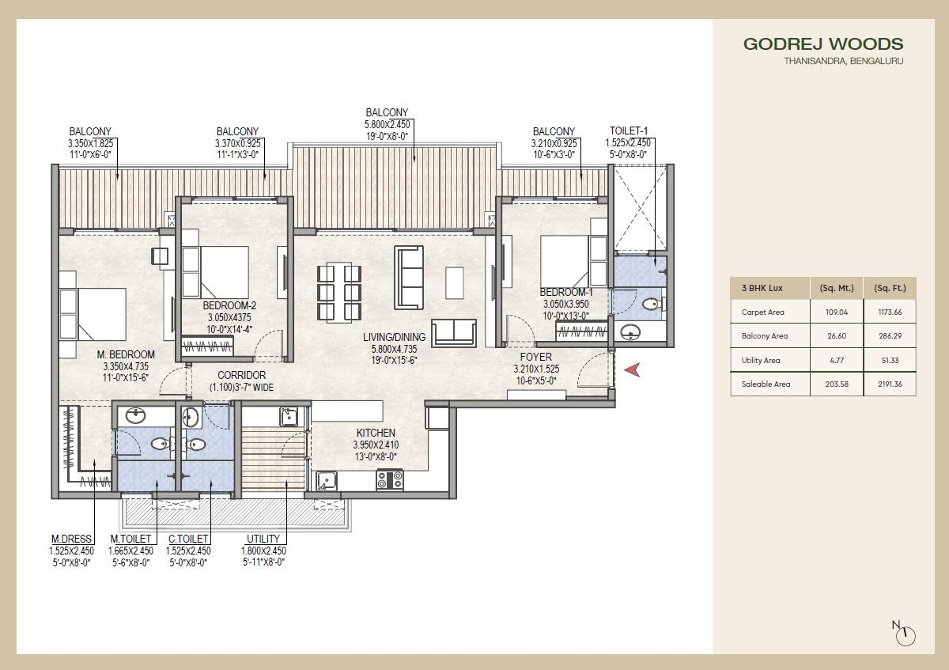

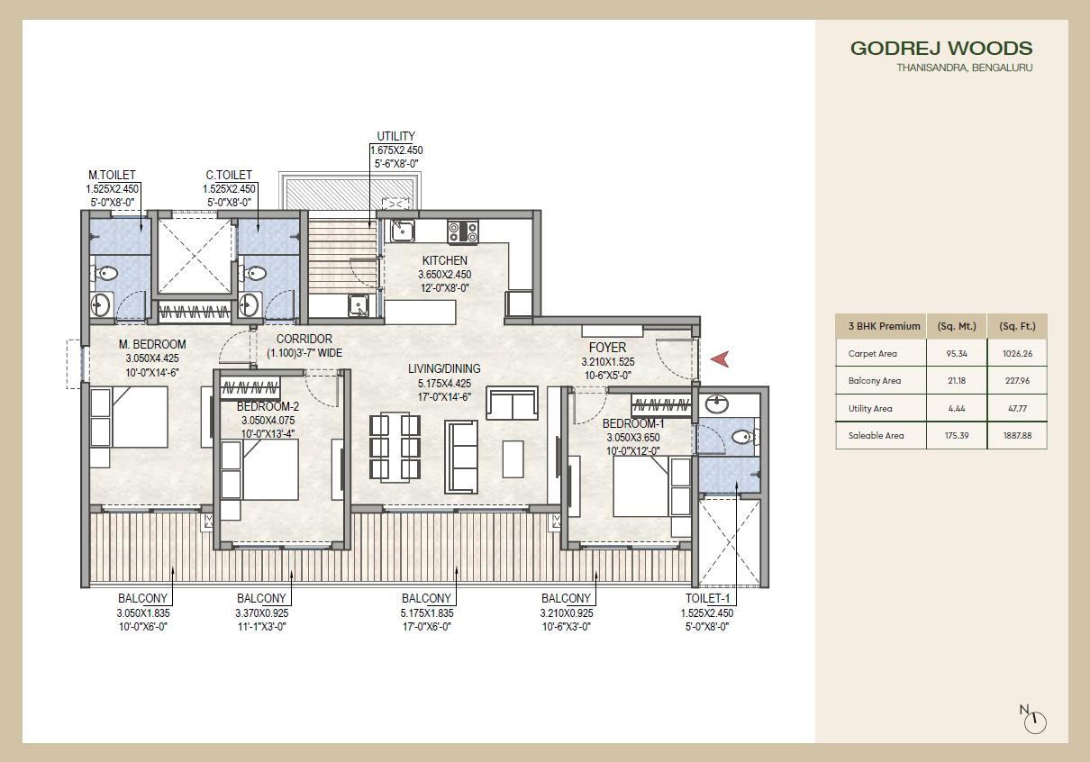

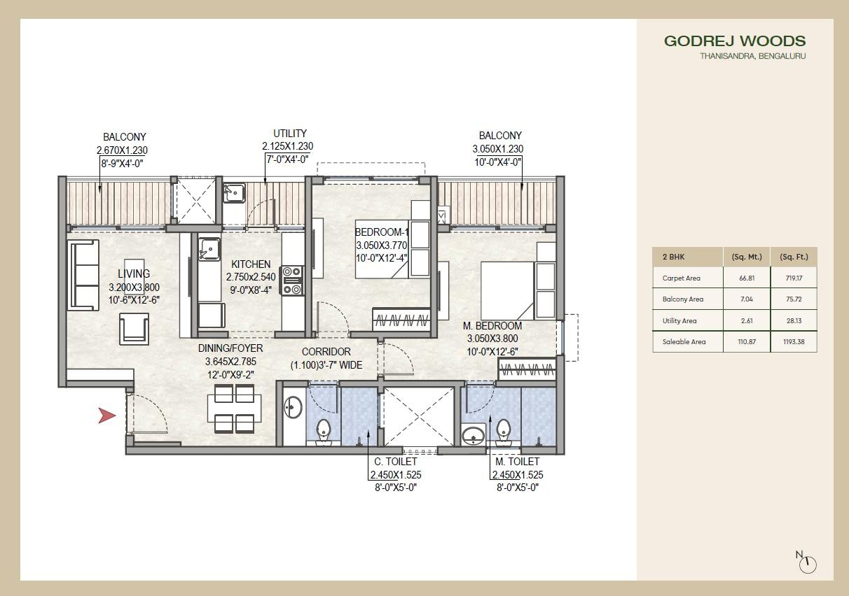

Location Advantages

  - Educational Institutes
    - REVA University - 2 min*
    - EuroSchool North Campus - 6 min*
    - Delhi Public School - 7 minutes*
    - Canadian International School - 10 min*
    - Mallya Aditi - 12 min*
    - CMR University - 12 min*
    - Stonehill International School - 18 min*
    - Vidyashilp University - 22 min*

  - Hospitals
    - Cytecare Hospital - 7 min*
    - Sparsh Hospital Yelahanka - 9 min*
    - Cratis Hospital - 16 min*
    - Aster CMI Hospital - 16 min*
    - Manipal Hospital, Hebbal - 30 min*

  - IT & Tech Parks

    - Bhartiya Centre of Information Technology - 7 min*
    - Manyata Tech Park - 12 min*
    - L&T Tech Park - 12 min*
    - KIADB Aerospace Park - 15 min*
    - Kirloskar Business Park - 18 min*

  - Entertainment & Leisure
    - Bhartiya Mall Of Bengaluru - 8 min*
    - Oia - 10 min*
    - Byg Brewski - 12 min*
    - Elements Mall - 12 min*
    - Decathlon - 12 min*
    - The Galleria Mall - 14 min*
    - Phoenix Mall Of Asia - 15 min*
    - Padukone-Dravid Centre For Sports Excellence - 18 min*

Micro Market Understanding

Location Overview
Thanisandra is one of North Bengaluru’s fastest-growing residential corridors, driven by:

  - Proximity to Manyata Tech Park
  - Connectivity to Hebbal, Airport Road & Outer Ring Road
  - Rapid infrastructure growth
  - Demand from IT professionals and investors
  - Emergence of premium residential developments

It has evolved from a peripheral location into a mid-to-premium housing market.

Employment Catchment

Major demand comes from employees working in:

  - Manyata Tech Park
  - Kirloskar Tech Park
  - Hebbal business district
  - Airport corridor offices
  - Upcoming tech and commercial hubs in North Bengaluru

Infrastructure Growth

  - Wider roads and flyover developments
  - Retail growth (malls, supermarkets, entertainment)
  - International schools and hospitals nearby
  - Strong social infrastructure supporting family buyers

- FAQs Used By Sales & Pre-Sales Teams

Total land area except the buffer zone ? | 6 acres & 37 Gunthas
What is the open space ratio ? | 76%
Construction area we are using in the project ? | 6099 sqmt
UDS of the project ? | ~26%
What is the civic amenities area? | 5% of plot area
Theme of the project ? | Forest Theme
List of amenities ? | Clubhouse, Swimming pool, Kids play area
Clubhouse area space ? | 20000 sq ft
We have seen the number of the trees , how many trees we have overall ? | ~350 fully grown trees
how many entry and exit we are planning  ? | Single entry/exit portal
What is the main road width? | 24 m proposed to be widened to 30 m
Which khata it is? | A khata
What is the land zoned for (residential, commercial, mixed-use)? | Residential
Are there any restrictions on construction height, FSI (Floor Space Index), or usage? | Tower Height- 41.45/44.4 metres, FSI -2.98
gap between unit to unit ? | Differs as per tower layout

Gap betweeen two towers ? | Differs as per tower layout
What is the type of construction used? (RCC frame structure, precast, etc.) | RCC Frame structure
what is the water source here? | Borewell, BWSSB

What makes this project unique compared to others in the market? | Limited appartments, lavish balconies, forest  themed development
Are there smart home features (e.g., video door phone, home automation)? | No
Is additional parking or storage space available for purchase? | No
Numbers of visitor parking? | 60
Where is the provision fo the stp , type of the stp plan? | SBR
What is the electric backup ? | 2 BHK- 0.8 Kw, 3 BHK - 1 KW
What is the strength and grade of concrete used? | Foundation-M35, Column- M45
What type and grade of steel is used for reinforcement? | Fe 550
Are solar panels, rainwater harvesting, or waste management systems included? | Yes
20-80 Freedom Offer FAQ | > pay 10% initially and the remaining closer to possession. > Home loan can start after initial payment of 10%
20-80 Freedom Offer Payment Milestones | > Advance towards booking - 5% > Within 15th days from date of booking - 5% > Within 30 days from date of booking - 10% > On receipt of Occupancy certificate - 70% > On notice of possession - 10%

Legal Disclaimers

The Project is registered as " GODREJ WOODS " with Karnataka RERA bearing Registration No. PRM/KA/RERA/1251/472/PR/121125/008248 at https://rera.karnataka.gov.in/ This Project is being developed by Godrej Properties Limited.

Site Address: GODREJ WOODS, KHATHA NO. 323/106/9&10, E PID NO. 2254233335, SY NO 106/9 & 106/10 KOGILU VILLAGE, YELAHANKA HOBLI, YELAHANKA, BENGALURU URBAN, KARNATAKA - 560064

The images contains artist's impressions. No warranty is expressly or impliedly given that the completed development will comply in any degree with such artist's impression as depicted. The sale is subject to terms of application form & agreement for sale. All specifications of the unit shall be as per the sale agreement between the parties.

*The prices mentioned are an indicative agreement value. Stamp duty registration, GST & other charges over and above the agreement value. Customers are advised to apprise themselves of the necessary and relevant information of the project(s)/offer(s) prior to making any purchase decision.

The official website of Godrej Properties Ltd. Is www.godrejproperties.com. Please do not rely on the information provided on any other website. *T&C Apply

